

**PROJECT REPORT**

**ESTIMATION OF BUSINESS EXPENSES**

**ST.JOHN’S COLLEGE PALAYAMKOTTAI**

**DEPARTMENT OF PHYSICS**

**TEAM MEMBERS**

***S.SUDALAIMUTHU SURESH***

***M.SIVA***

***C.SELVI***

***A.STEFINA***

***Estimation of business expenses***

## *Introduction:*

This report delves into the fascinating realm of business expenses and provides a visual exploration of the various expenditures incurred by different businesses. It showcases the distribution of expenses, identifies key cost drivers, and highlights areas of potential optimization or concern. The visual representations allow for intuitive analysis, facilitating a deeper understanding of expenditure patterns and their implications for business performance.

*PURPOSE:*

Decision-makers, financial analysts, and stakeholders can gain valuable insights into the financial health of businesses, identify areas of inefficiency or opportunity, and make informed decisions to optimize resources and drive growth. To Extract the Insights from the data and put the data in the form of visualizations, Dashboards and Story we employed Tableau tool

***PROBLEM DEFINITION & DESIGN THINKING:***

# Empathy map:

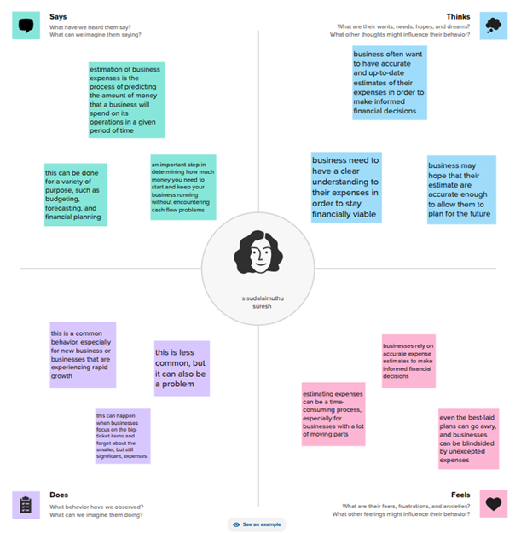

***IDEATION & BRAINSTORMING MAP***

## brainstorming:

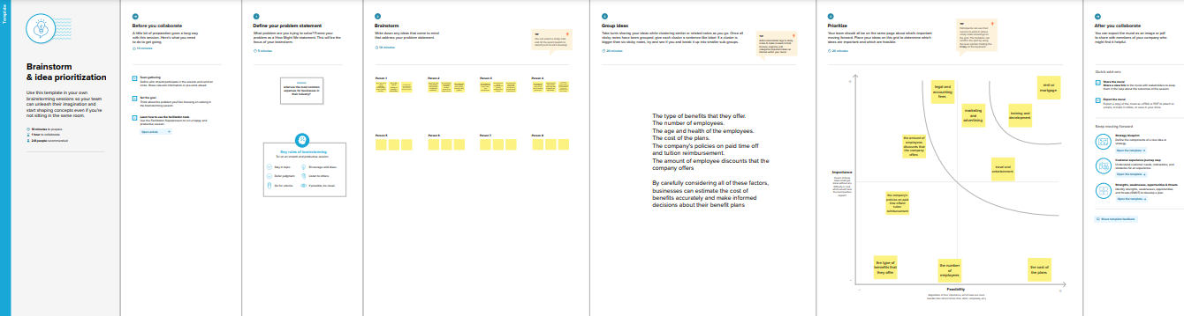

***RESULT:***

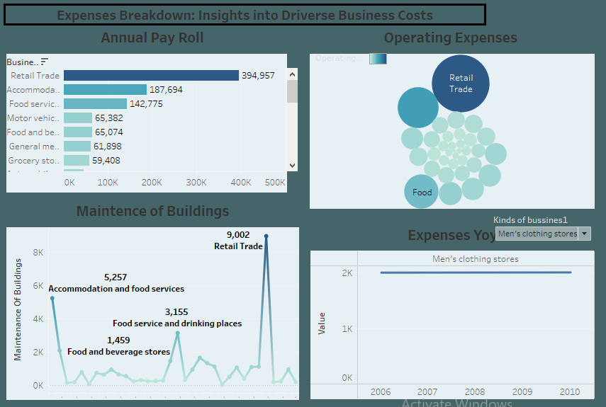

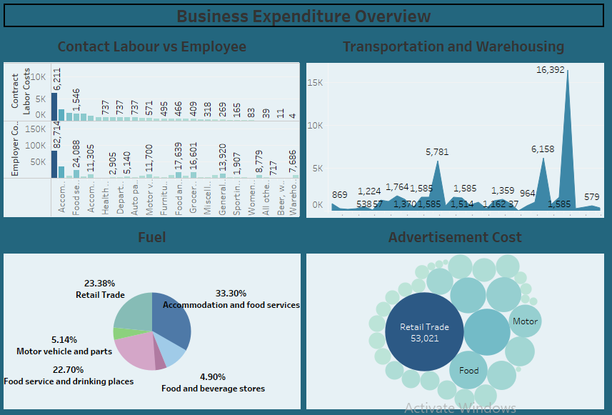

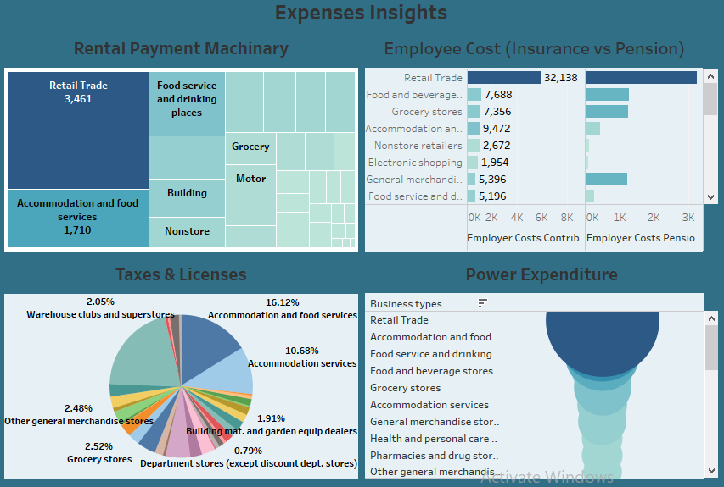

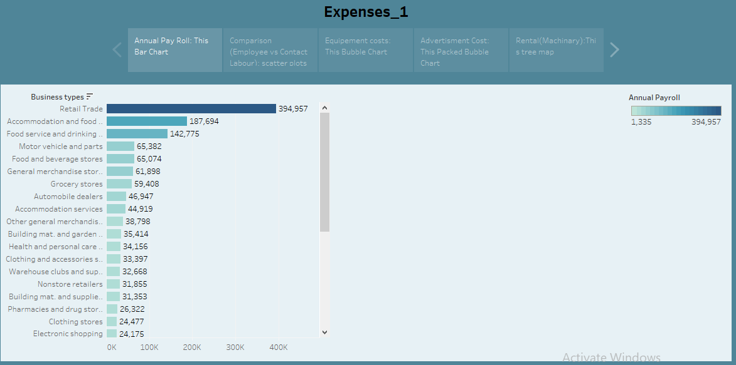

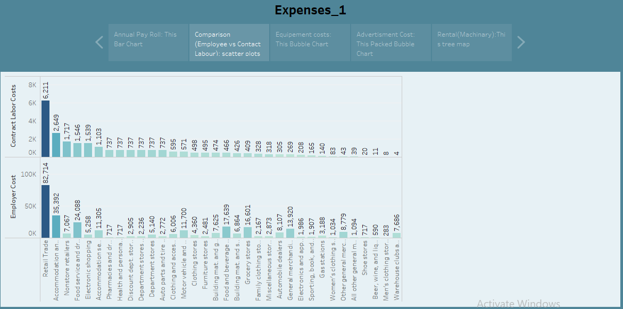

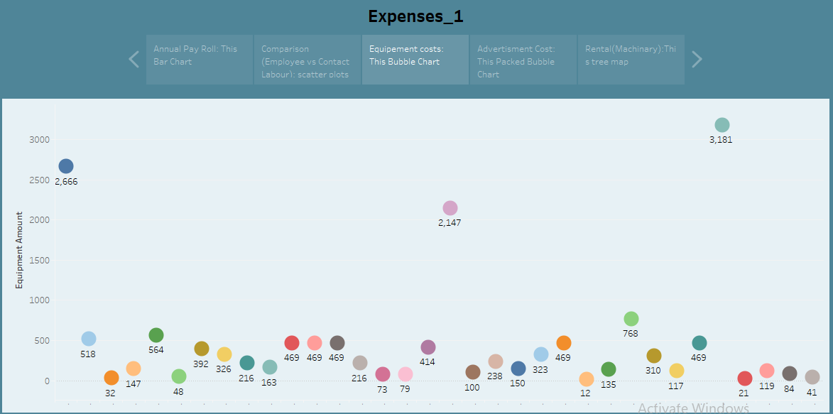

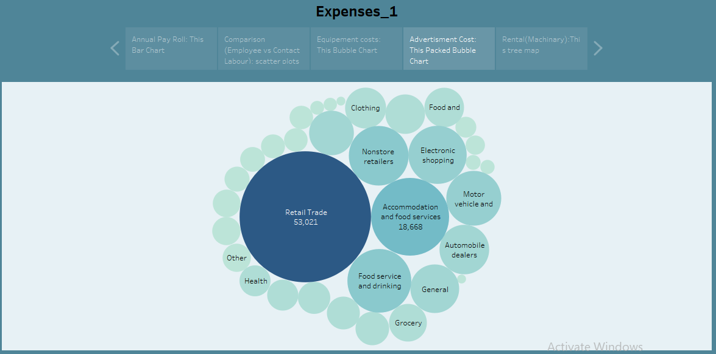

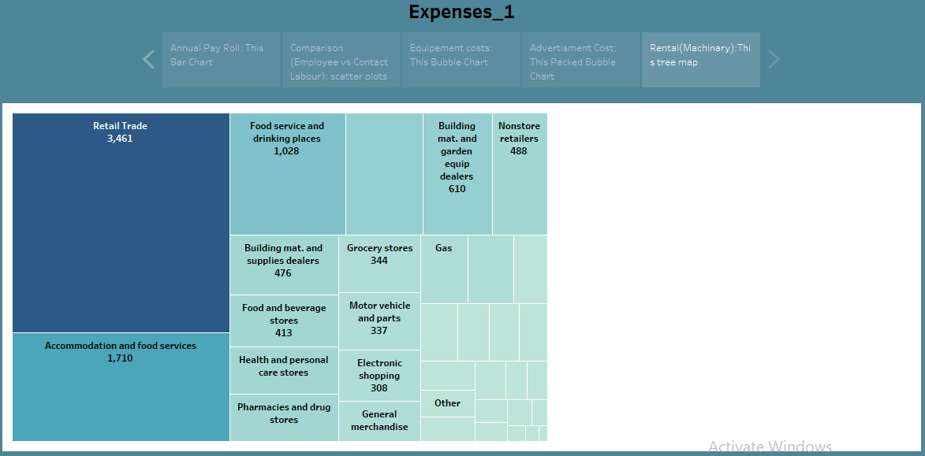

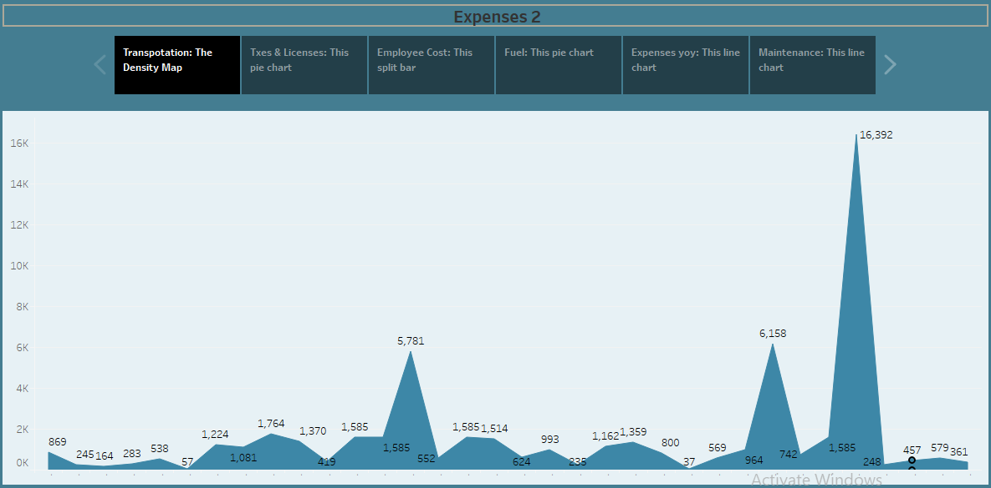

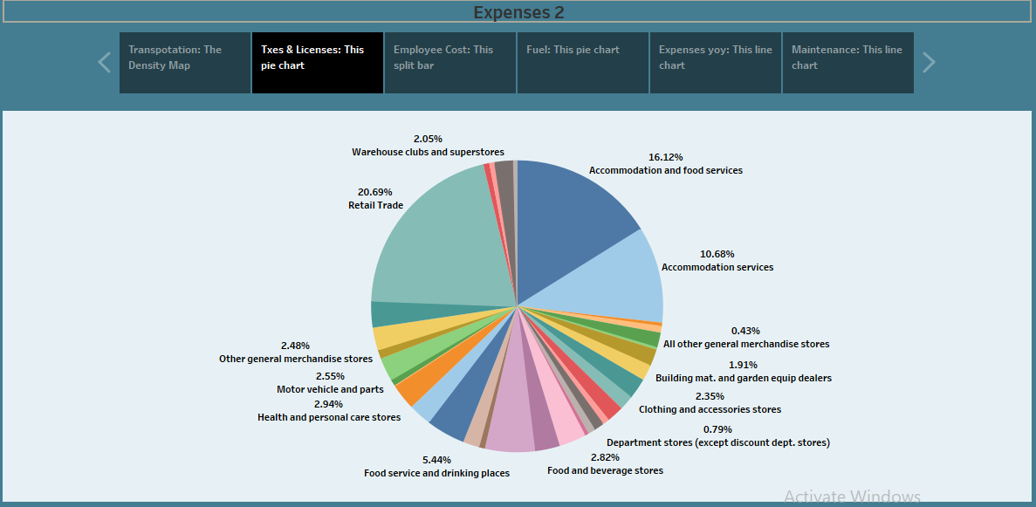

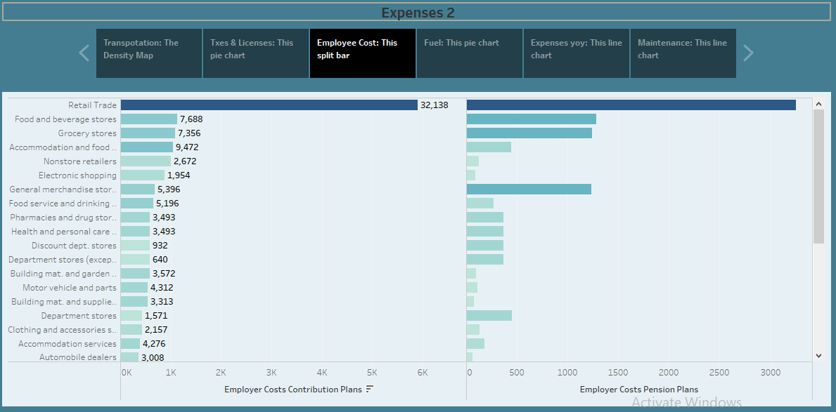

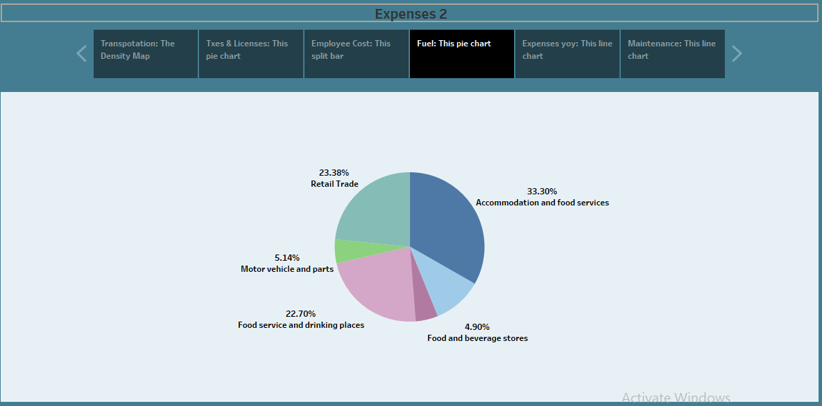

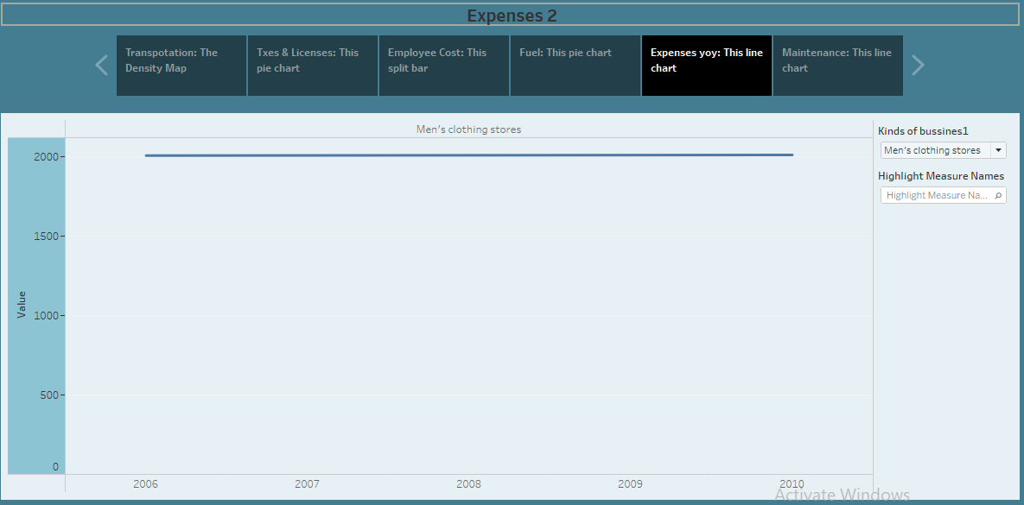

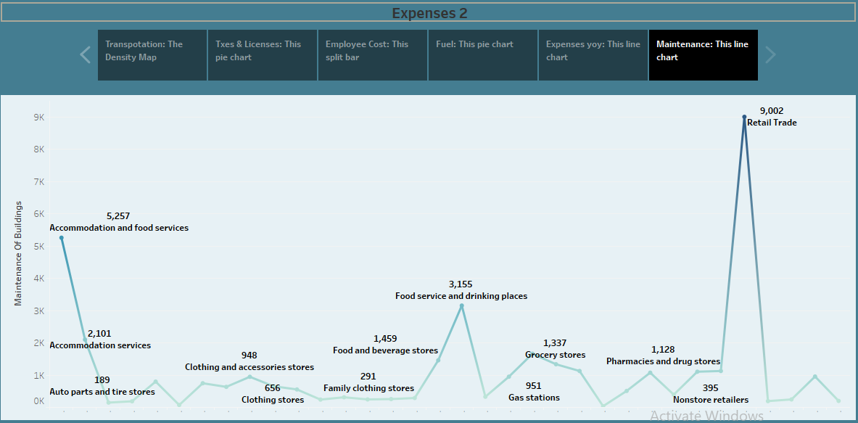Disadvantage: It is less reliable for old properties as it is difficult to estimate the depreciation of properties that are older.

***ADVANTAGES:***

* **result in smoother execution of the project**
* **Save Money on Projects. More accurate estimations Complete Projects Faster. The right estimation means glitch free, uninterrupted project execution**
* **It allows you to know whether you need to raise the price of your product or if you can keep it at a steady cost.**
* **Estimating business costs involves knowing your profit margins, accurate estimating of the time that will take, and considering the risks involved with completing the job.**

***DISADVANTAGES:***

* **needing more complex and costly accounting systems and procedures to track and record the actual costs of each production cycle.**
* **It is less reliable for old properties as it is difficult to estimate the depreciation of properties that are older.**
* **potential job losses, lower quality products, and less customer satisfaction**

***APPLICATIONS:***

* **An estimation of business expenses application is a tool that helps businesses estimate their future expenses. This can be useful for budgeting purposes, as well as for forecasting cash flow*.***
* **There are a variety of different estimation of business expenses applications available, both free and paid.**
* **These applications typically allow users to input their business's historical expenses, as well as their projected expenses for the future. The application will then generate a report that shows the user how much they can expect to spend in each category**

***CONCLUSION:***

**cost estimation is an important component of project management that ensures projects are finished on schedule and within budget**

***FUTURE SCOPE:***

**The estimation considers various factors like scope, schedule, resources, and risk. Costing considers actual expenses, including labor, materials, equipment, and overhead. Basis: It is based on historical data, expert judgment, and available information*.***